“ADS: Assignment-2”

1. Print 1 to n without using loops

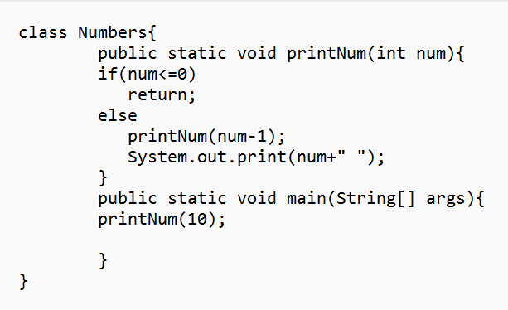

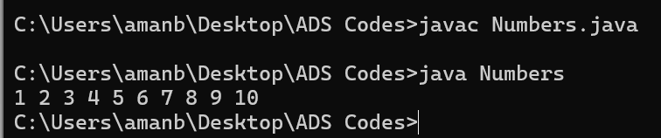

1. Sum of natural numbers using recursion.

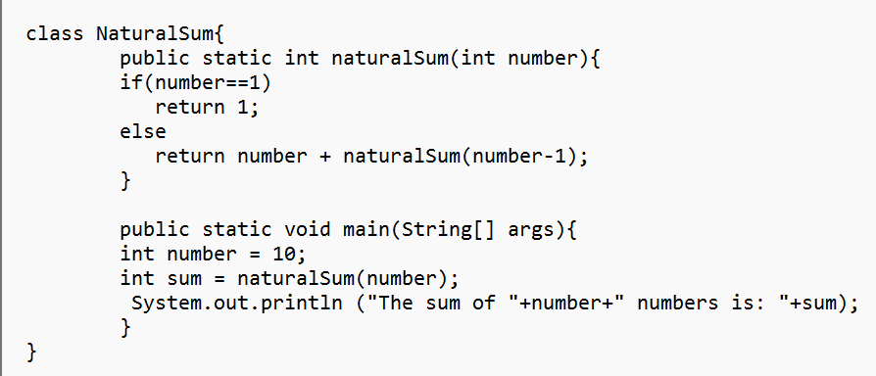

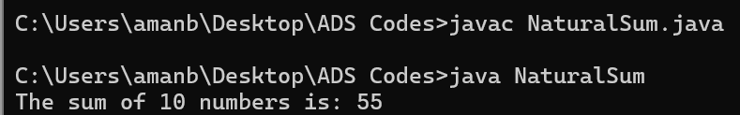

1. Mean of array using Recursion.

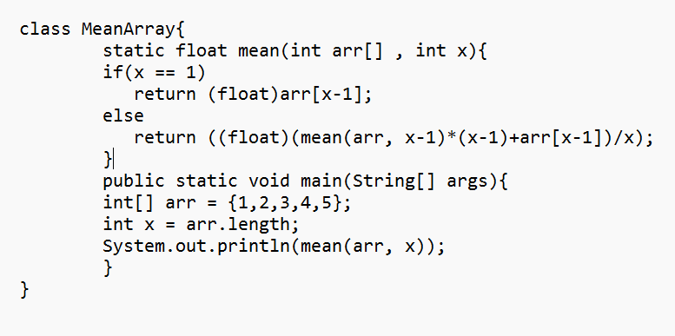

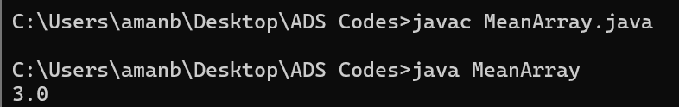

1. Sum of array elements using recursion.

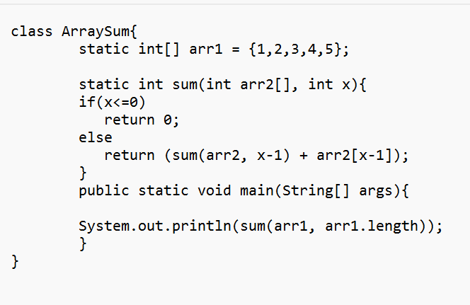

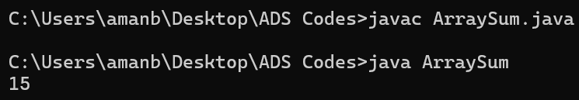

1. Sum of digit of a number using recursion.

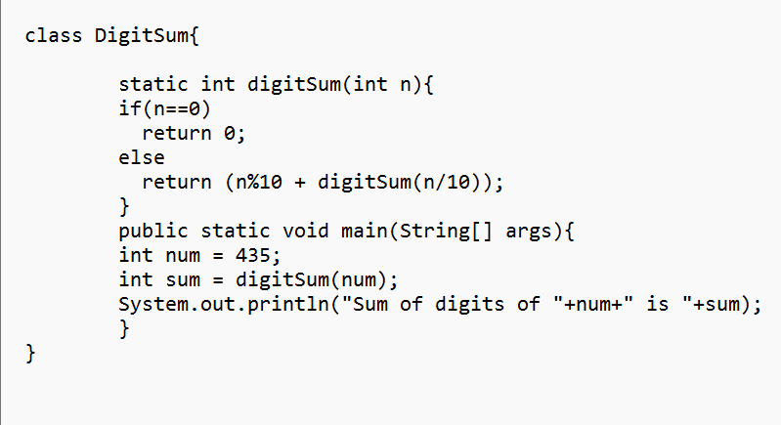

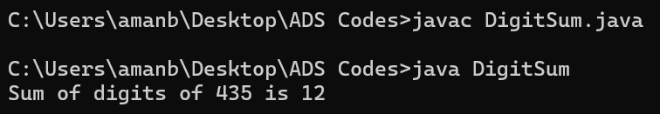

1. Print reverse of a string using recursion.

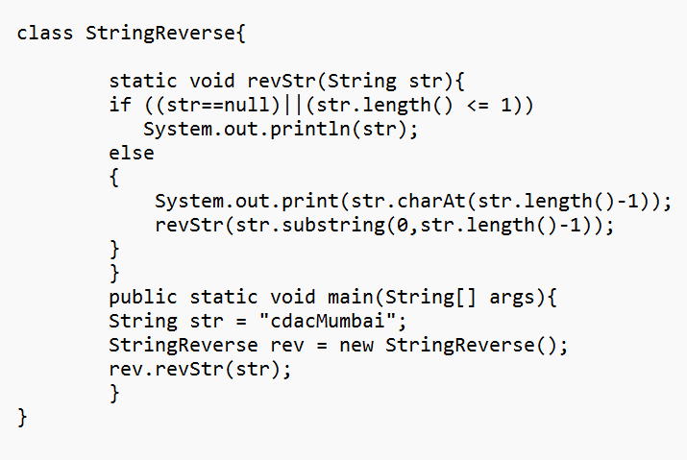

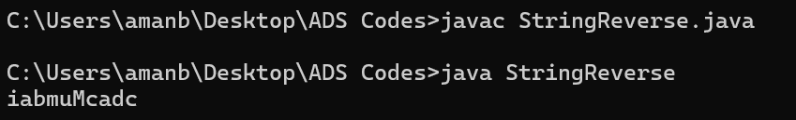

1. Program for length of a string using recursion.

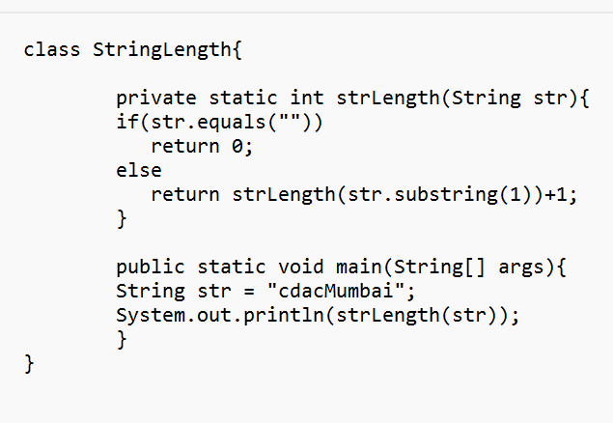

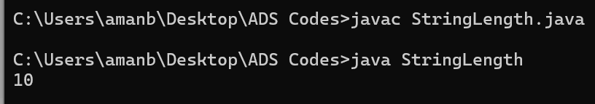

1. Tail recursion to find sum of an array elements.

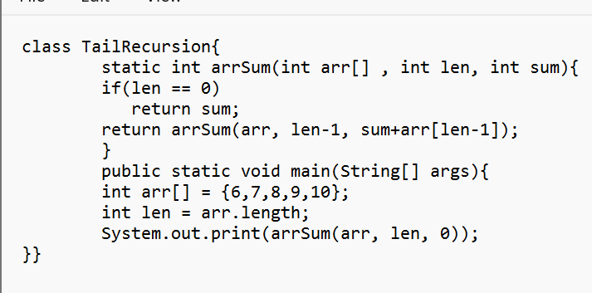

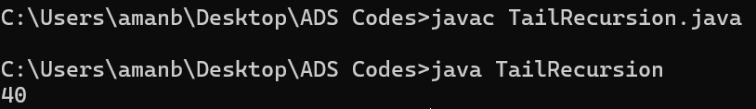

.9. Recursive function to check if a string is palindrome

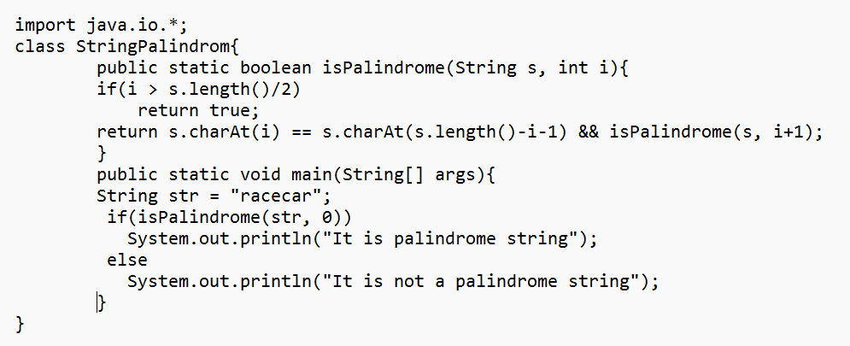

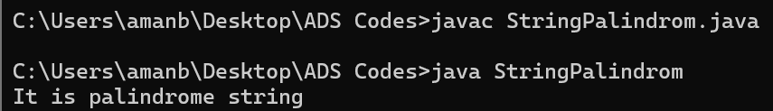

10. Print Fibonacci Series in reverse order using Recursion

